# **QuickStart User Guide**

* **Requirements:**
  + Python 3.x
  + Web Browser (Chrome, Edge etc.)
* **Project Setup and Installation**
  + Firstly, download and extract the project files.
  + Now in the project workspace open a command prompt and write the following command to install all the project dependency

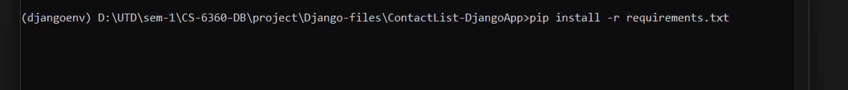

* + After this all the dependencies will be installed, and your workspace environment will be setup
  + Now, you can start a terminal and run the following command
  + **Graphical user interface, text

    Description automatically generated**
  + This will start the Django server and now you can go the URL provided below in your browserText

    Description automatically generated
  + This will start the application and it’s ready to use.

**App Walkthrough**

* When you open the URL in your browser and start the app

This home page of application will be opened

* You can Add New Contact Details in this page.
* There is also an option to add multiple Address, Numbers and Date
* Upon submit it will store all the details in the database and will redirect you to search page.

**Search Page:**

* In the search page you can search for a particular details of a contact as well as edit/delete the contact.
* You can also navigate to add new contact using top-navbar
* When you submit Edit button
* A screenshot of a computer

  Description automatically generated
* Update page opens with All details of that user.
* You can edit as well as add new details and it will be updated in the database
* Same way when you select delete it will delete all the details of that user from the database.